NEA Project Log & Testing

Jacob Halleron
The Sandon School

Log
Date | Note
2021-03-22 | Created analysis document.
2021-03-25 | Wrote “market research” section of analysis document. Emailed my client about the details of the project.
2021-04-01 | Initialised git repository so that my code isn’t just stored on my laptop. Started using git commit messages rather than a word processor for the project log.
2021-04-04 | Created “readme” file for GitHub.
2021-04-19 | Updated the project analysis document by writing the proposed solution section.
2021-04-22 | Initialised NPM so I can run JS files with imported modules. Also installed Express, the web server module.
2021-04-22 | Created basic web server along with index.html that links the other pages, 404 page and a test page which I’ll use to test the bar chart visualiser. Also created basic stylesheet.
2021-04-22 | Tried to run git push but the previous commit was on a school computer, so my laptop’s local repository was behind the online repository. I had to use git pull, then commit and push.
2021-04-26 | Moved web server address from localhost:8080 to localhost:80 so that it doesn’t interfere with my other programs. I should stop coding for now, I don’t have proper documented design for the project.
2021-05-06 | Added model section to analysis ODT.
2021-05-21 | Moved the to do list to the proposed solution section and wrote the objectives section based on emails with the client.
2021-05-24 | Tweaked the to do list, specifically the site design.
2021-05-27 | Added git ignore file so that git doesn’t upload the relatively chunky node_modules directory to the online repository.
2021-06-17 | Started work on the project design document. Designed some of the bar chart class.
2021-07-17 | Implemented a crude function that draws a bar chart. I haven’t yet encapsulated it into a visualiser class so it’s pretty messy for now. Also added bogo sort, the simplest algorithm I could think of.
2021-07-29 | Tweaked the CSS and added a few buttons so that I can (mostly) interact with the page without relying on the console.
2021-08-06 | Added bubble sort and a visualiser class. Also added a list in the HTML that gets automatically updated with the variables of the currently running algorithm. The whole thing is still very buggy.
2021-08-08 | Didn’t add any new features, but I did clean up the code. Encapsulated most functions and variables into the SortChart class. I’m naming the classes “charts” rather than “visualisers”, I think it’s easier to read.
2021-08-23 | Made sure the getters and setters of the SortChart class all made sense and worked as one would expect. Also added the `interval` property so that the speed can be changed.
2021-08-24 | Added insertion sort. Also added sound effects so that the page beeps and boops for different heights of bar. It isn’t appropriately distributed using the complex maths yet.
2021-09-06 | Started on the tree and graph drawing algorithms. Created a HTML and JS file for each, similar to the bar chart. It should be easier since I’ve already figured out the groundwork, the main difference will be the draw function. The bar chart is very slow for larger inputs, the time for one cycle is capped at about 5ms. I’ll need to optimise the script so that I run the drawing function every frame (60Hz) rather than every time I update the array to eliminate pointless unseen drawing.
2021-09-07 | Added more comments for better code readability and tidied up the design document with all the methods and variables in tables.
2021-09-09 | Added small startup script for operator efficiency. It should save a few seconds whenever I want to run the server in future.
2021-09-12 | Optimised bubble sort and added “boggle sort”, a made up combination of bogo and bubble sort because it seemed fun. In the end I’ll want the graph, tree and barchart classes in the same file for better load times and simpler layout, so I’ve added a basic “Chart” parent class and started moving the methods over.
2021-09-26 | Moved the project log back from the git commit messages to this document using a word processor, it will look more complete when the project is done.
2021-09-28 | Explained my algorithm code format better in the design document, I think it makes sense now.
2021-10-11 | Added substantial comments to all scripts, documents and the style sheet.
2021-10-18 | Planned the tree drawing algorithm in the design document. It turns out to be trickier than expected to generate coordinates for nodes in a tree, so I’ll be using the “Reingold-Tilford algorithm” which I found in a blog post from 2014: https://rachel53461.wordpress.com/2014/04/20/algorithm-for-drawing-trees/
2021-11-07 | Restructured the directories so that all the code is in `src` and all the meta documents are in the `doc` folder. This is how most other projects I’ve seen are laid out.

Testing

2021-04-22
Problem: Web server won’t start up. The code looks pretty boilerplate, and I expect “server alive” to be printed to the console at startup, but instead I get this error message:
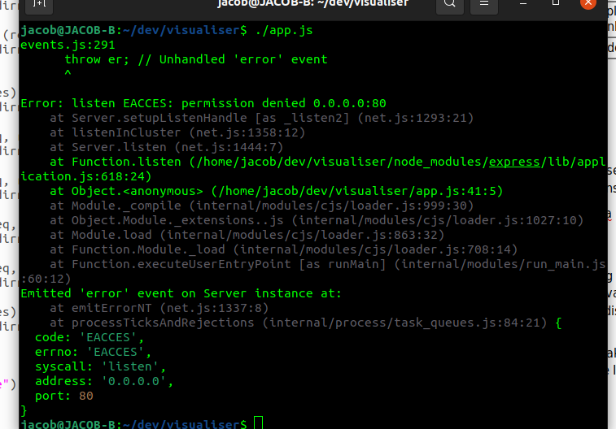
Solution: I realize I’ve set the server to listen on port 80 (for HTTP), which requires root privileges to access. I’ll make sure to write `sudo ./app.js` rather than just `./app.js` in future.

2021-08-24
Problem: Trying to make sound effects work. I expect there to be a smooth stream of legato tones of varying pitch and currently, they exists but sound choppy and disjointed. Every time the displayed pointer moves, a new oscillator is created that plays the sound and is deleted.
Solution: I’ll make one oscillator for each chart on initialisation, but set its volume to zero. Every time I need a sound, I’ll make the volume high enough and give it the correct pitch.

2021-09-06
Problem: Added a tree class but the method to recursively generate branches only creates some of the tree. Here is the current output:
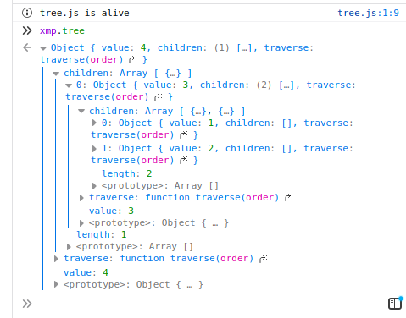
It returns a tree that is 3 nodes deep, but only contains 4 nodes rather than 13.
Solution: The problem is that the `i` from the method’s for loop is not reset when the function is called again. I forgot to use the `let` keyword before the `i = 0` to make it have function scope rather than global scope.

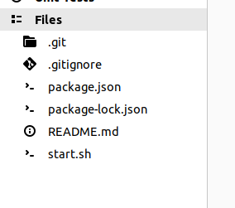
2021-11-07
Problem: All code seems to have disappeared. I expect there to be a folder named `src`, maybe I accidentally deleted it? I hope not.
Solution: I forgot to run `git add *` earlier when I restructured the folders, so git missed that one out last time I uploaded to the repository.

2021-11-08
Problem: The tree drawing algorithm requires that I access a tree node’s siblings, but this is impossible with my current methods. I can only access a given node and its children.
Solution: I’ll need to completely change my tree class to allow for this. Currently a node’s children are a property of that node, and I’ll change it so that the `children` property is only an array of references to other nodes. Basically, trees will now be a subclass of graph.

